ENERGY PERFORMANCE CONTRACTING
Czech Republic & Austria

Jaromír Čtrnáctý
Joachim Kalkgruber

Content
1. EPC Method – Basic Principles 3
1.1. How does the method work 3
1.2. Usage of the EPC method 5
1.3. EPC contract 5
2. History of using and spread of the EPC method 6
2.1. EPC in the USA 6
2.2. EPC in the Czech Republic 6
2.3. History of using and spread of the EPC method in Austria 7
3. Current State of the EPC method in the Czech Republic 8
3.1. Spread of EPC and common measures 8
3.2. EPC market in the Czech Republic 9
3.3. Current State of the EPC method in Austria 9
4. Comparison: Czech Republic and Austria 12
5. Literature: 13

- EPC Method – Basic Principles
As we know, energy prices (electricity, heat and oil) have been constantly growing within the last years and decades and they are likely going to rise in the future as well. Decreasing high energy costs can help to save reasonable amounts of money. However, there are a few obstacles, due to which the energy consumption and cost is still rather growing than decreasing. The most important of them are for example the lack of available investment resources, lack of human resources and the overall complexity of energy savings issues. One of the methods which can help to overcome these problems, is the EPC method.
  - How does the method work
The EPC method (shortcut of „Energy Performance Contracting“) was developed in 1970´s in the USA. The main output of this method is a contract between the company (often called as ESCO – Energy Service Company) and the customer (a private company or a public sector institution).

The main point of the method consist in that the ESCO evaluates the current state of the chosen objects concerning the energy consumption and savings potential, makes a proposal of energy saving measures and realize these measures at its own expenses. At the same time ESCO guarantees that the overall energy costs will decrease to a certain level (e.g. by 20 %) compared to the state before the measures. Parts of these savings are then annually (during the contract which means 6-8 years) paid to the ESCO to repay the investment. To sum up, the basic rule is that the customer repays all the cost connected with the saving measures just after they have been realized and have started to generate the savings.

The ESCO guarantees that a certain minimal savings level will be reached. If not, the customer pays to the ESCO just as much money as he has saved thanks to the realized saving measures. Thus, the customer has a guarantee that he will not pay more for energy as he would pay if he haven´t signed any EPC contract. After the term of the contract (6-8 years) the customer gets annually whole the amount of the energy savings. Moreover, the customer does not have to have enough investment resources or know-how.

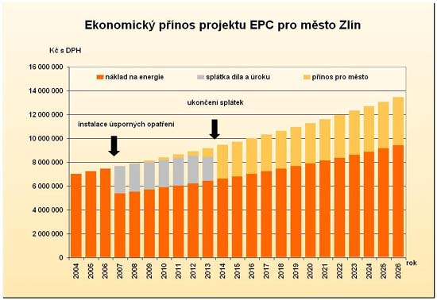
Economic model of an EPC project
Figure 1: Growing columns (relating to years) show the assumed growing energy cost for the case „bussiness as usuall“ – which means no measures. Energy consumption is stabilized or growing, energy prices are growing annually, hence energy cost are growing too. After the measures realization the energy cost sink and the customer repays a certain part of the saved money to the ESCO. After the contract expires, all the saved money belongs to the customer. The customer at any moment pays more for energy, than he would pay without the EPC project.

Translation notes:
axe x: years of contract
axe y: energy costs
orange color: energy costs
grey color: payments of the customer to the ESCO
yellow color: net gain for the customer

The main benefits of the EPC method for the customer are as following:
- Reasonable decrease of energy consumption (up to 40 %)
- Decrease of other operational costs, especially for maintenance
- Access to outer financial sources
- Property modernization without using own financial sources
- 100 % guarantee of the supplier – zero risk for the client
- Improvement of the user´s comfort
  - Usage of the EPC method
Within EPC projects consumption-side short-term returnable measures are mostly realized, the rate of return is never above 10 years. Therefore, among the common measures belongs e.g. a heat system regulation or monitoring of the energy consumption in the building. Less often it can be wider measures like boiler change or optimization of the distribution grid. From non-investment measures staff training is the most usual. On the other hand, the EPC method is usually not used for wider long-tern returnable investments like window change or insulation.

  - EPC contract
EPC contract is an important document which should cover whole the relationship between the ESCO and the customer. Details can differ from case to case, but there are a few basic points which should be clearly specified in any contract:

Baseline energy cost
Before they sign the contract, the ESCO and the customer have to agree on a so-called baseline cost. If both sides of the contract are to be able to identify the cost savings during the contract, they have to set a predicted „business as usual“ cost level in advance. „Business as usual“ (BaD) means that the customer would do no saving measures in the years of the contract. The BaD cost level is then derived from the suggested energy consumption (which may be stabilized) and from the suggested energy prices (which are likely to grow continually).

Customer obligations
There are many obligations like that the customer has to provide all technical information and support needed, he has to pay a certain part of the savings back to ESCO etc. One of the most important obligations is mostly that the customer will not do any sufficient saving measures on his own, unless ESCO is informed and agrees with that. This is because of the identification of the cost savings rate, which have been reached thanks to the ESCO.

There are many other specifications and many technical attachments in the contract. The length of the contracts usually exceeds 30 pages.

- History of using and spread of the EPC method
  - EPC in the USA
The EPC method belongs to a wider family of so called “energy services”. It has been developed in 1970´s and early 1980´s in the USA, partly as a reaction to the first and second oil crisis. Initially, it has been developed as a tool for public sector, which generally has neither enough investment resources nor know-how to realize reasonable energy savings on it´s own. Later on the method has spread to the private sector, although with some alternations. These days, the US market is the most developed energy services market in the world. Public as well as the private sector know and trust the model of EPC projects, the stakeholders are used to the long-term contracts and EPC providing companies are represented by several cover organizations, among which NAESCO (National Association of Energy Service Companies) with hundreds of members is the biggest one.

  - EPC in the Czech Republic
As for Czech Republic, the first EPC projects have occurred quite early after the Velvet revolution, in 1993. Most of our first performers have gained experience in the USA. However, there has never been such a “boom” of this method in the Czech republic like in US. There were several reasons – the complexity of the energy savings issues was hard not only for the customers, but even for the first performers to go through. Czech banks hadn´t have any experiences with financing such kind of projects and were not willing to give bank credits for them. Next the customers were not used to such long-term contract relationships. Some of less successful realizations have also damaged the name of the method itself. The situation started to get better around the year 2000, when some of the previous ESCO companies started to provide also trainings and seminars, mainly for the public sector representatives. The awareness of the method is nowadays slowly rising and up to dozens of new EPC projects are initiated every year. However, the real “boost” of EPC and other energy services is probably still ahead.
  - History of using and spread of the EPC method in Austria
In many countries, the application of the energy performance contracting model in financing energy-saving measures is not (yet) very widespread. The introduction of new procedures often requires both contracting parties to make increase efforts in terms of organisation.

Nevertheless, there is no information about when the first EPC project in Austria was launched, but you can find an increasing interest in the years around 1996.
For instance in a lots of international meeting they started to discuss about adequate models for contracting in Austria.

A first estimation of the market potential of contracting in Austria was done in 1997. The following table (Figure 2) summarize the most important facts for the potential of Energy Performance Contracting market in the investigated markets in the service sector (1 € = 13,76 öS).

Sub-segment | Potential volume of investment | Share of contracting projects | Energy savings in sub-segment by contracting
Public authorities | 584 Mill. öS | 55% | 97 Mill. öS/a
Schools | 584 Mill. öS | 22% | 106 Mill öS/a
Hospitals | 584 Mill. öS | Heat: 45 %  Electricity: 60% | Heat: 35 Mill öS/a  Electricity: 62 Mill öS/a
Hotels | 1380 Mill. öS | 56% | 230 Mill. öS
Figure 2

The phrasing and handling of the contract are relatively demanding. Smaller investments and / or low cost savings will therefore not be attractive – neither from the third party financing company´s point of view, nor from that of the client. For that reason EPC is not spread out in the thermal restoration in the household sector. Possible solution: a smaller building could be included in a project together with several other buildings.

But the market grew and grew and so the 27th June 2005 the most powerful Austrian contract providers founded an association. The aim was to develop further the EPC-market in Austria, to gain the highest energy savings and to establish modern facilities with the newest status quo.
The association will concentrate his activities to make the market transparent, to upgrade the quality of services and to provide information for potential clients.
- Current State of the EPC method in the Czech Republic
  - Spread of EPC and common measures
Although the EPC method was developed primarily for the public sector, it can be just as good used in the private sector. The customer subject has to be just big enough, so that the cost savings is reasonably high. This is the reason why EPC method is not used for private persons (family houses, single flats etc.) – Transactions costs connected with the complicated contract compared to a potential savings are too high in such cases. Nevertheless, from the two main customer groups – private companies and public bodies – is the second one more important. There are several reasons why there are more EPC projects in the public sector. At the demand side it is the fact that especially big private companies and factories sometimes have their own experts on energy issues and they are able to realize some saving measures on their own. Anyway, the main reasons are at the supply side: since the EPC contract is long-term and therefore risky, ESCO companies tend to cooperate with public bodies, which, unlike private companies, cannot bankrupt.
As for the measures, which are most usually realized within EPC projects, rate of return does play the main role. ESCO companies have to invest in such measures, which will repay themselves within a few years. Typical investment measures in buildings are as following:

- heating system regulation
- warm water supply optimizing
- energy management (energy consumption monitoring and targeting)
- new boilers or generators installation
- new pumps
- insulation of the distribution grid
- waste heat usage
- monitoring and measuring software, etc.

Along with these capital measures, there are often non-investment measures like training courses for the maintenance staff, data evaluation etc. All these measures (especially the capital ones) have their rate of return below 5, maximally 10 years.

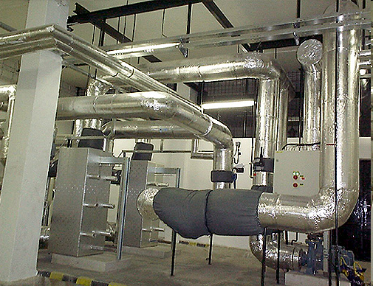
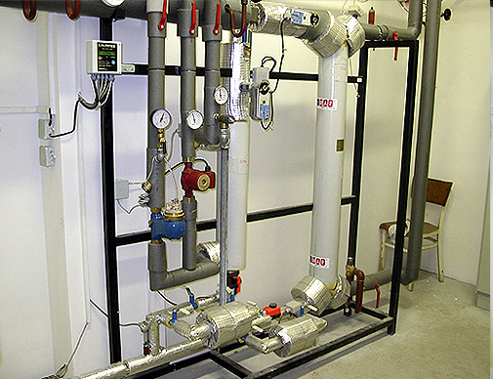

Figure 3: Heat supply after application of EPC saving measures

  - EPC market in the Czech Republic
These days, there is slightly more than 10 ESCO companies in the Czech republic and the overall amount of successfully completed EPC projects reaches approximately one hundred. There is no official cover organization of ESCO companies in the Czech republic, however some of the bigger companies are informally gathered in a working group by the Czech Chamber of Commerce. This group has meetings a few times a year. The companies are trying to set some basic rules for the market, to coordinate their customers´ education policy and last but not least they have created a model EPC contract which should make dealing with the customer more efficient and transparent. This collaboration of competing companies may be surprising for the first sight, but the reason is obvious: The potential market of energy services in the Czech republic is huge and by far not developed yet. The companies now are in a common process of “creating the Czech energy services market”.
  - Current State of the EPC method in Austria

In the last few years the market of energy contracting was indicated by a huge increase. This further going development gives the clients the advantage to choose between a huge amount of suppliers to gain the best offer. Because of the strong expansion of this sector lots of clients have the problem to get an overview about the suppliers who offer energy contracting.

To inform potential clients about contracting and to make it easier to find the proper client for contracting, the Austrian Energy Agency by order of BMUJF (Bundesministerium für Umwelt, Jugend und Familie) made an overview about the Austrian companies which offer contracting.

By 2004 about 40 companies were announced who offer contracting. The companies are single but there is a covering organization called DECA (Dachverband Einspar Contracting Austria) It was founded in 2005 with the goal to create a common representation of interest for the contracting providers.

Nevertheless there are more addresses, where one can get informed about EPC projects and companies: For instance the Austrian Energy Agency, the contracting portal of Austria or the energy agency of Styria.

To guarantee the quality of a contracting program a seal of approval was developed. Thermoprofit® is a brand and was developed within an impulse program which is supported by the city of Graz, the chamber of economy Styria and the state of Styria. The aim is to encourage the market for contracting and to give adequate support for ownerships of buildings.

Another symbol which is more popular is the Umweltzeichen. Under http://www.umweltzeichen.at/article/archive/1140 you can see which companies got the Umweltzeichen for energy contracting.

Every company has certain business activities. From thermal solar energy systems and biomass heating districts to biogas aggregates is everything available. By 2004 109 projects have already been realized. Up to now there are even more.

The majority of these objects are schools, hotels, old people´s homes or public buildings, but also projects for baths, zoos and private industrial companies have been realized.

In most of the projects they renew the heating, ventilation and cooling systems, optimize the peak load management and illumination, install some heating recovery systems or some thermal solar power plants. But also measures like insulation of building or windows change is done. For instance in 1999 46 schools in Vienna got a better insulation of the upper ceiling.

In Haslau-Maria Ellend the primary school got in the year 2000 new modern plastic windows, a new illumination, a calorific value boiler and thermostatic valves. With these measures they save about 6 % of costs per year.

Concerning to private industry there is still a lack of contracting.
A few reasons can be:
- There is no know-how about profitable measures for energy efficiency.
- Energy is not an important issue for them. Investments are concentrated on the area of productivity of the company.
- Investments in energy efficiency decrease other possible investments.
- The company bears the complete risk of the investment.

In the pilot project SAVE II they tried to push the contracting in industry. The aim was to give an impulse for a stronger application of contracting by initiate pilot projects and by a better support for potential savings contracting clients.
Four recommendations are given to enforce contracting in private industry:

Tipp 1: start easy – but keep on going
Measures for energy efficiency in the industrial sector are generally more complex than for example in the area of buildings. To determine the baseline for checking of savings can be relatively complex. It is recommendable to start with a simple approach and not to start with the whole system, for instance compressed air, motors or illumination.

Tipp 2: clear definition of borders
To concentrate on a subsystem you have to know the borders of it.

Tipp 3: Never disturb production process
Investigations have shown that the main fear of companies is that it can come to a possible standstill in the production process. The costs, which are connected with such a standstill, can affect the cost-benefit ratio very strongly. Because of that, it´s a must to think about the least disturbance already at planning time.

Tipp 4: Use tools for the reduction of credit risk of the contractor
Creditworthiness of the company must be approved by the contractor. There are some possibilities like:

- Bank guarantee, but this means, that the project is getting more expensive
- To shorten the time of amortisation by reducing the time of risk, it doesn’t decrease credit risk

Especially for Austria it is important to develop certain standards. For example to standardize the calculation of the baseline or to develop modules for contracts is a certain need. Also there is a need for better information about contracting for industry.
- Comparison: Czech Republic and Austria
In my opinion the EPC method is more or less spread out equally in Czech Republic and Austria. Also the measures for Energy Contracting Performance are the same. There are no certain differences of technology they use to save energy. Normally they just renew the heating district like they switch from oil to gas or biomass in Austria. Maybe a difference can be that in Austria the use of thermal solar power is spread out wider for energy savings.

In context with organisation we founded out that in Czech Republic there is still no covering organization like in Austria. Also the absence of certain quality symbol for contracting providers is also missing in the Czech Republic.
But also in Austria there is space for improvement, like the development of certain standards.
For example to standardize the calculation of the baseline or to develop modules for contracts is a certain need.
Also there is a need for better information about contracting for industry.

What is similar to Czech and Austria is that the industry needs special attention for EPC. There is a huge market of energy savings, costs and tons of carbon dioxide.
The aim must be to give an impulse for a stronger application of contracting in private industry.

- Literature:
Leutgöb K; et al. (1997); Drittfinanzierung in Österreich, Modelle zur praktischen Umsetzung, Zusammenfassung des Endberichtes Wien, März 1997; ISBN: 3-901381-30-9

EnergieAgentur.NRW: NRW spart Energie. Informationen für Wirtschaft und Verwaltung, Ministerium für Wirtschaft, Mittelstand und Energie des Landes Nordrhein-Westfalen, 2007, 44 pgs.

Grazer Energy Agency (2000) EPC Manuel, Preparation of an EPC project: From the first idea to realisation

Leutgöb K; et al. (1998) Einspar-Contracting in der Praxis; Wien Dezember 1998;

Internet sources:

Database of ESCO companies and EPC projects: Enviros, s.r.o., cited 11th February 2009, internet access: http://www.epc-ec.cz/

www.naesco.org (National Association of Energy Service Companies)

